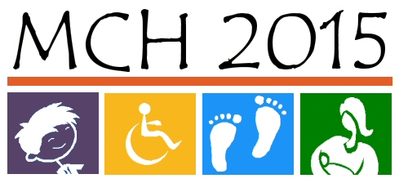
VISION: HEALTHY CHILDREN IN HEALTHY FAMILIES

MISSION: Provide leadership to enhance the health of Kansas women and children in partnership with families and communities

Children & Youth with Special Health Care Needs

GOAL: To enhance the health of all Kansas children and youth with special health care needs across the lifespan

Priority #1: All CYSHCN receive coordinated, comprehensive care within a medical home
Strategy 1.1: Inform, educate, and involve families and providers about medical home components and initiatives to promote effective and successful systems change.
Strategy 1.2: Mobilize community partnerships (between policy makers, health care providers, families, and the public) by coordinating services for eligible CYSHCN and linking children and families to providers and community services/resources.

Priority Objective #2: Improve the capacity of YSHCN to achieve maximum potential in all aspects of adult life, including appropriate health care, meaningful work, and self-determined independence
Strategy 2.1: Enhance community partnerships by identifying community resources, integrating service delivery systems, and streamlining the transition process for children and youth.
Strategy 2.2: Inform and educate children, youth, and families about available transition services and where/how to access these services.

Priority #3: Financing for CYSHCN services minimizes financial hardship for their families
Strategy 3.1: Link families to providers who are contracted with or referred by the CYSHCN program and accept negotiated reimbursement rates.
Strategy 3.2: Ensure CYSHCN Clinic/Field staff assist families in applying for and maximizing benefit of funding sources and family supports.
Strategy 3.3: Support expansion of primary and specialty care services to minimize travel time and missed work/school days.

